Reverse a Doubly Linked List
Problem Statement: Given a doubly linked list of size ‘N’ consisting of positive integers, your task is to reverse it and return the head of the modified doubly linked list.
Examples

Example 1:

Input Format:

DLL: 1 <-> 2 <-> 3 <-> 4

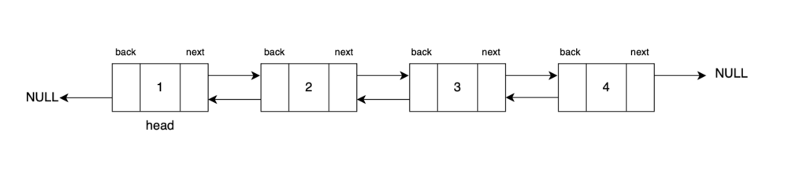
Result: DLL: 4 <-> 3 <-> 2 <-> 1

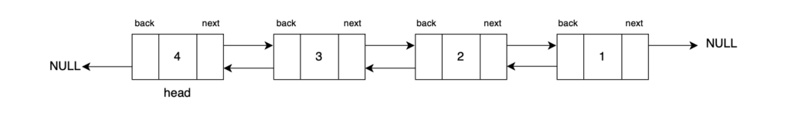
Explanation: The doubly linked list is reversed and its last node is returned at the new head pointer.

Example 2:

Input Format:

DLL: 10 <-> 20 <-> 30

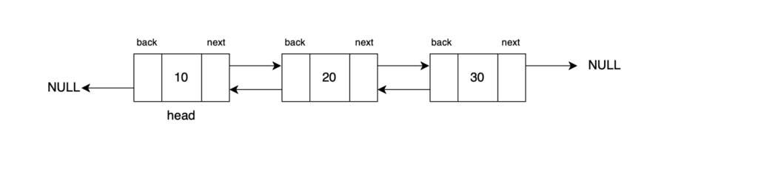
Result: DLL: 30 <-> 20 <-> 10

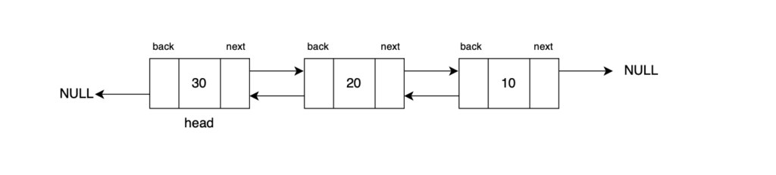
Explanation: In this case, the doubly linked list is reversed and its former tail is returned as its new head.
Optimal Approach
Algorithm / Intuition
Reverse the Links in a Single Traversal
Instead of performing two separate traversals of the linked list and storing its node values in an external data structure, we can optimize our approach by directly modifying the links between the nodes within the doubly linked list in place, as visualized below:
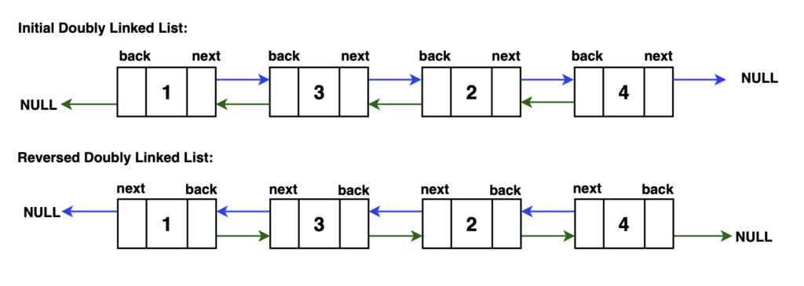
We need to traverse on every node, and for every node change the next pointer and back pointer. If we can do this for all nodes, at the end of traversal, the doubly linked list will be reversed.
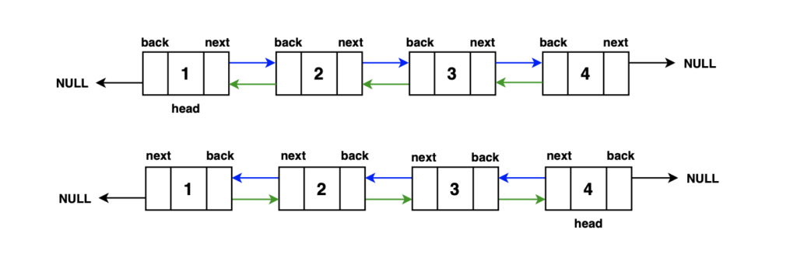
Algorithm:
Step 1: Initialise two pointers that are needed for the reversal. Initialize a current pointer to the head of the linked list. This pointer will traverse the list as we reverse it. Initialize a second pointer last to null. This pointer will be used for temporary storage during pointer swapping, as we need a third variable while swapping two data.
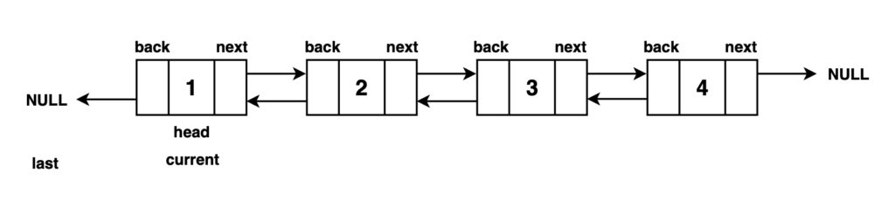
Step 2: Traverse through the DLL by looping over all the nodes..
Step 3: While iterating over all nodes in the linked list, we make changes to set the backward pointer of a node to the next changing its previous link. Along with this, the forward pointer is adjusted to point to the previous node, reversing the next link. To prevent losing the last node in this process, we use a reference to the last node to retain it.
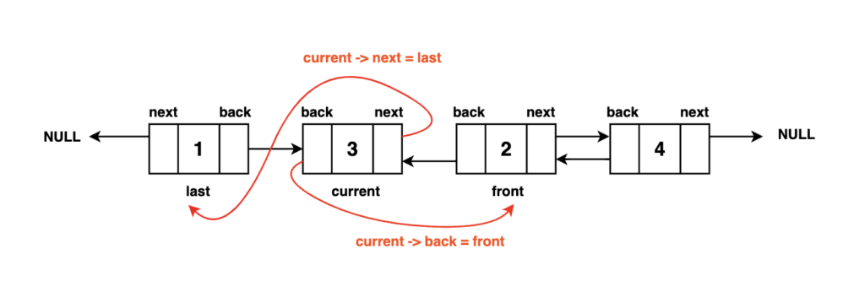
- Update the current node's back pointer to point to the next node (current->back = current->next). This step reverses the direction of the backward pointer.
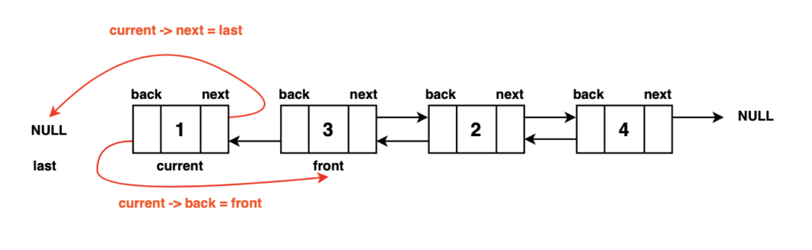
- Update the current node's next pointer to point to the previous node (current->next = last). This step reverses the direction of the forward pointer.
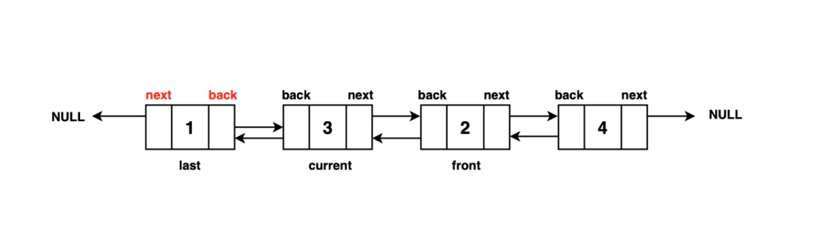
- Move the current pointer one step forward (current = current->back). This allows us to continue the reversal process.
Step 4: After completing the traversal, the last node ends up at the second node in the reversed doubly linked list. To obtain the new head of the reversed list, we simply use the backward pointer of the last node, which points to the new head.
To ensure that we handle the case where the traversal ended at the original list's end (i.e., the last pointer is not null), we update the head pointer to point to the new head of the reversed list, which is stored in the last pointer.
Finally, we return the head pointer, now pointing to the head of the fully reversed doubly linked list.
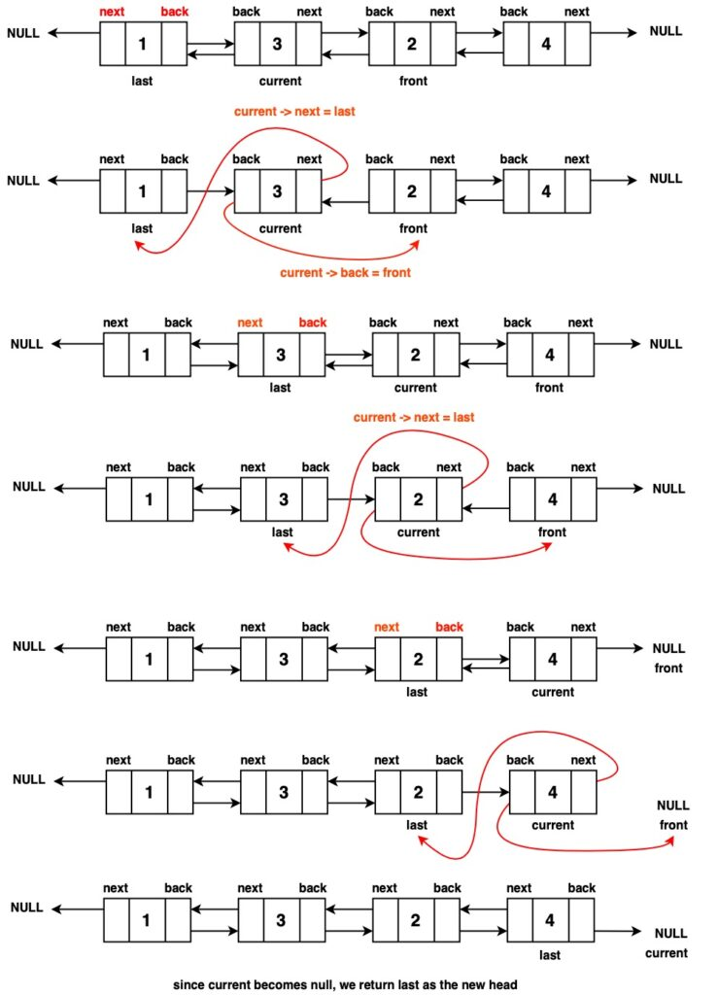
Code

import java.util.Stack;

public class DLinkedList {
public static class Node {
// Data stored in the node
public int data;
// Reference to the next node
//in the list (forward direction)
public Node next;
// Reference to the previous nod
//in the list (backward direction)
public Node back;

// Constructor for a Node with both data,
//a reference to the next node, and a
//reference to the previous node
public Node(int data1, Node next1, Node back1) {
data = data1;
next = next1;
back = back1;
}

// Constructor for a Node with data,
//and no references to the next and
//previous nodes (end of the list)
public Node(int data1) {
data = data1;
next = null;
back = null;
}
}

private static Node convertArr2DLL(int[] arr) {
// Create the head node with the
//first element of the array
Node head = new Node(arr[0]);
// Initialize 'prev' to the head node
Node prev = head;

for (int i = 1; i < arr.length; i++) {
// Create a new node with data from
// the array and set its 'back' pointer
// to the previous node

Node temp = new Node(arr[i], null, prev);
// Update the 'next' pointer of the
// previous node to point to the new node

prev.next = temp;
// Move 'prev' to the newly created node
//for the next iteration
prev = temp;
}
// Return the head of the doubly linked list
return head;
}

private static void print(Node head) {
while (head != null) {
// Print the data in the current node
System.out.print(head.data + " ");
// Move to the next node
head = head.next;
}
System.out.println();
}

private static Node reverseDLL(Node head) {
// Check if the list is empty
// or has only one node
if (head == null || head.next == null) {
// No change is needed;
// return the current head
return head;
}

// Initialize a pointer to the previous node
Node prev = null;

// Initialize a pointer to the current node
Node current = head;

// Traverse the linked list
while (current != null) {
// Store a reference to the previous node
prev = current.back;
// Swap the previous and next pointers
current.back = current.next;
// This step reverses the links
current.next = prev;
// Move to the next node in the orignal list
current = current.back;
}
// The final node in the original list becomes the new head after reversal
return prev.back;
}

public static void main(String[] args) {
int[] arr = {12, 5, 6, 8, 4};
Node head = convertArr2DLL(arr);
System.out.println(“Doubly Linked List Initially: “);
print(head);
System.out.println("Doubly Linked List After Reversing :");
head = reverseDLL(head);
print(head);
}
}
Time Complexity : O(N) We only have to traverse the doubly linked list once, hence our time complexity is O(N).
Space Complexity : O(1), as the reversal is done in place.

